CS 255 System Design Document Template
Aaron Albrecht

UML Diagrams

UML Use Case Diagram
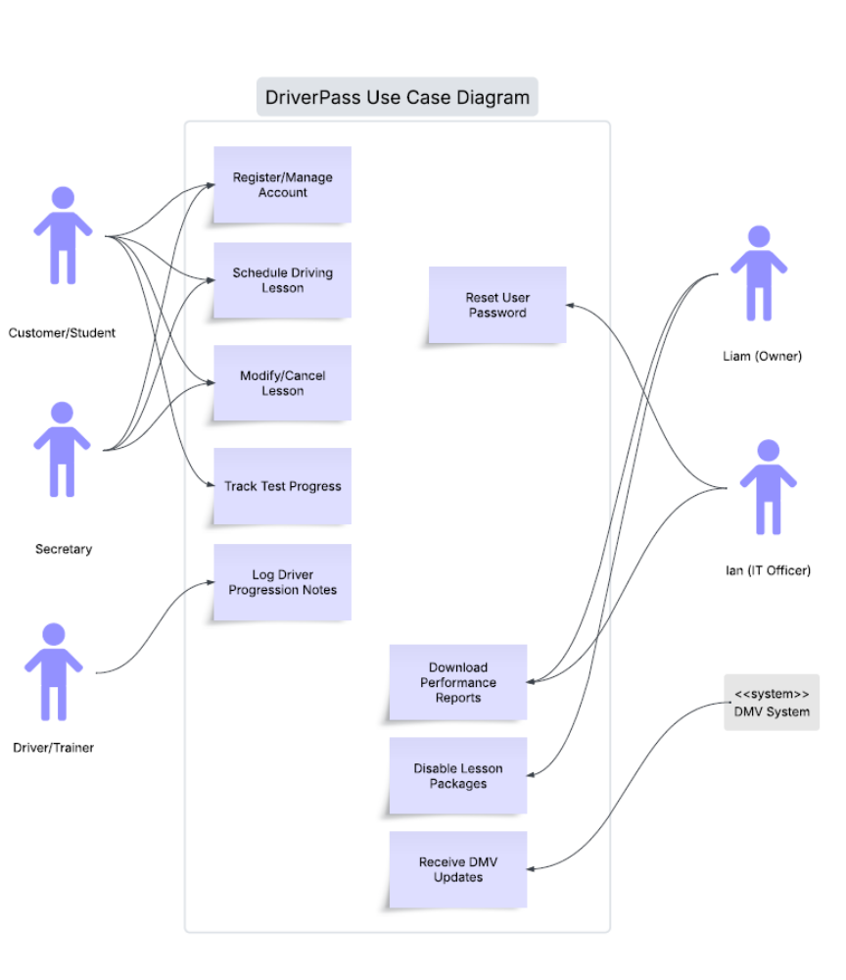

UML Activity Diagrams
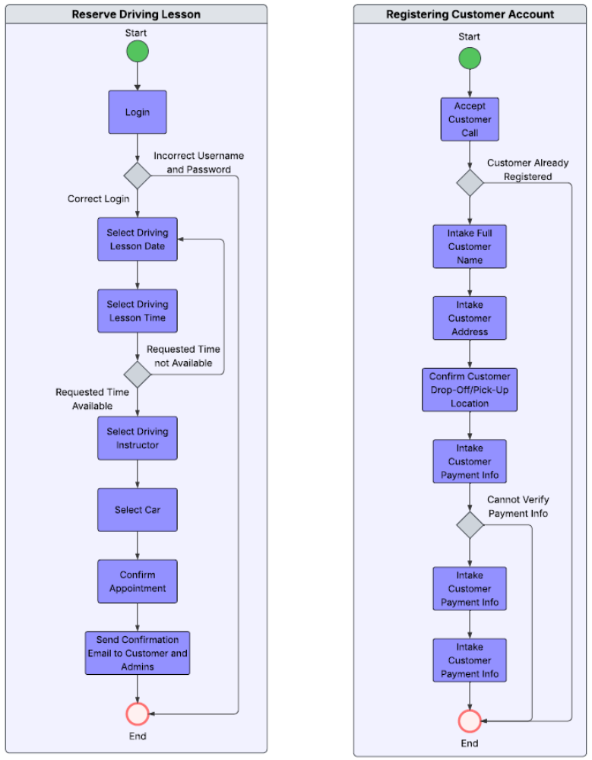

UML Sequence Diagram
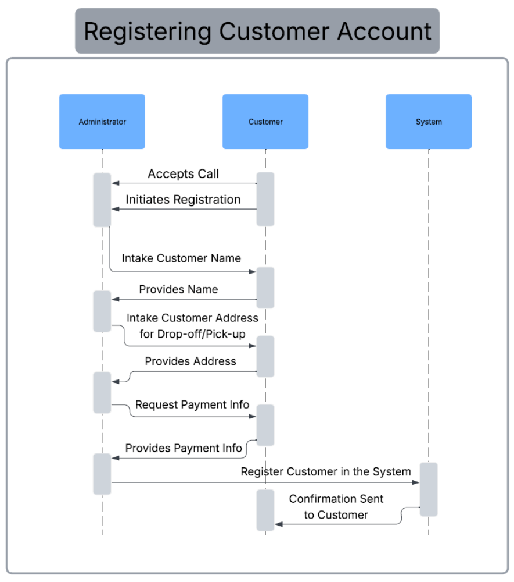

UML Class Diagram
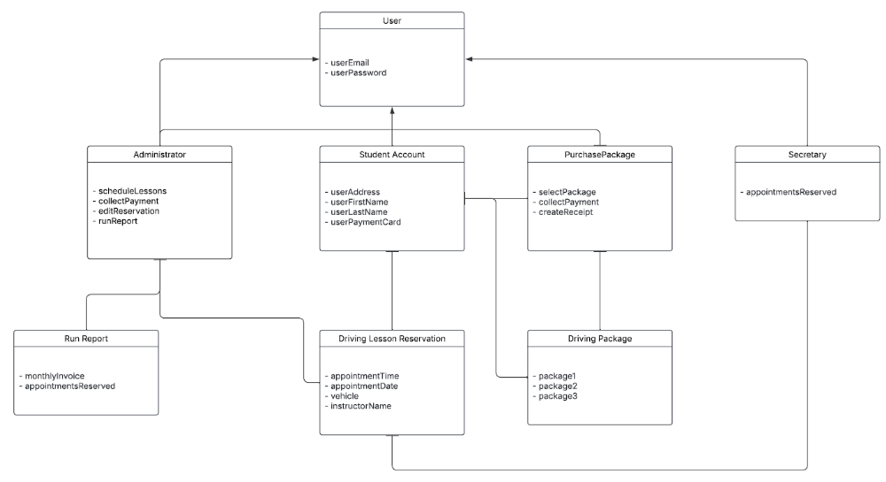

Technical Requirements

Because this is a smaller business looking to expand, a cloud-based server would be recommended for its cost and scalability. Computers using Windows would be a preferred option to give the staff of DriverPass to use to fulfill their assigned roles/responsibilities. A reliable internet connection is required for staff to access the database, receive updates from DMV, make reservations/create accounts, and run reports. Having an automated system back-up to handle customer/administrative information and a security system to protect that information from viruses/hackers is paramount. Being able to access DriverPass’s portal from any device whether Windows, macOS, or a mobile device is necessary to ensure the largest possible customer pool.

